**CSCI Final Project**

Alegarbes, Deekimcheng, Lee, Felipe, Tan

**Appendix**

1. Bar Charts

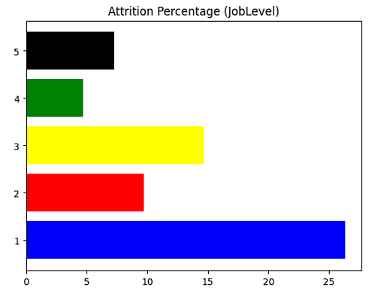

Fig. 1a Attrition Percentage by Job Level

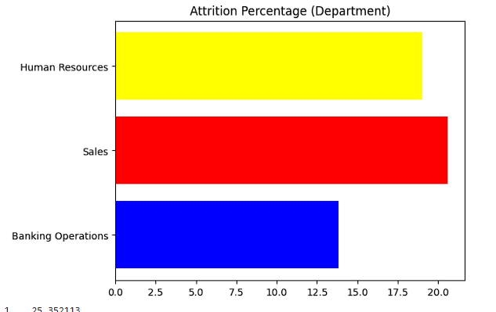

Fig. 1b Attrition Percentage by Department

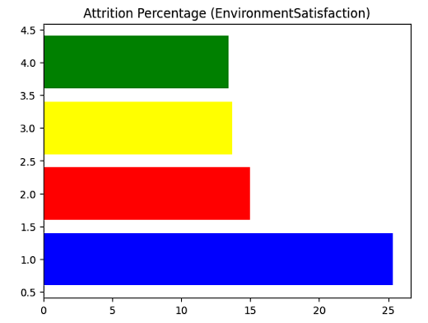

Fig. 1c Attrition Percentage by Environment Satisfaction Score

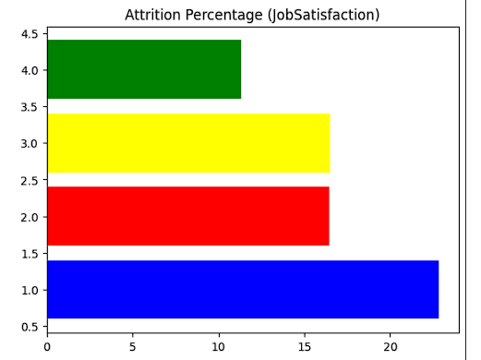

Fig. 1d Attrition Percentage by Job Satisfaction Score

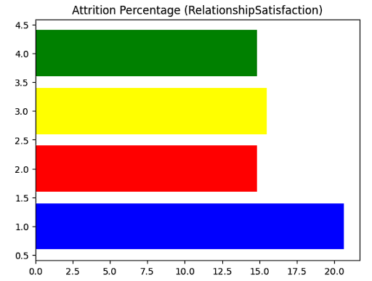

Fig. 1f Attrition Percentage by Relationship Satisfaction Score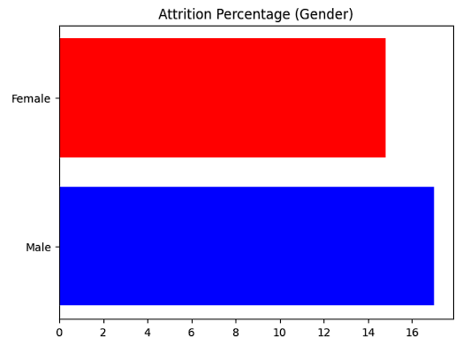

Fig. 1g Attrition Percentage by Gender

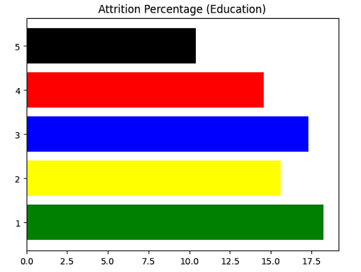

Fig. 1h Attrition Percentage by Education

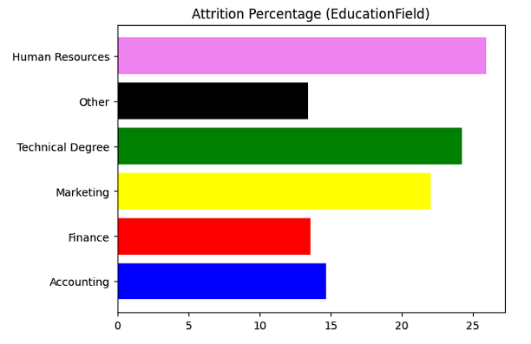

Fig. 1i Attrition Percentage by Education Field

1. Pie Charts

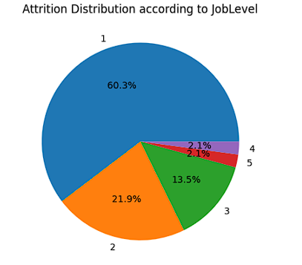 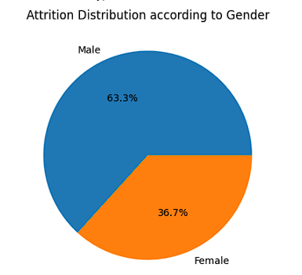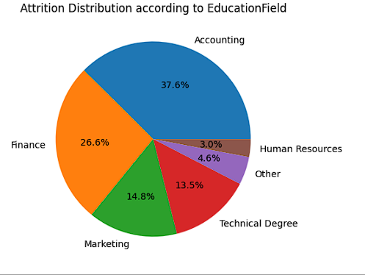

Fig. 2a Attrition Distribution by Job Level

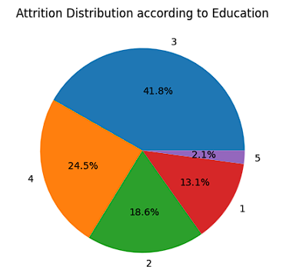

Fig. 2b Attrition Distribution by Education

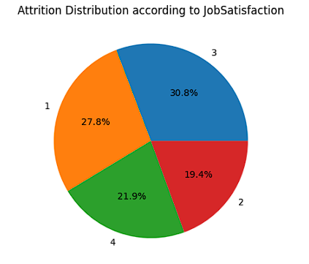

Fig. 2c Attrition Distribution by Job Satisfaction Score

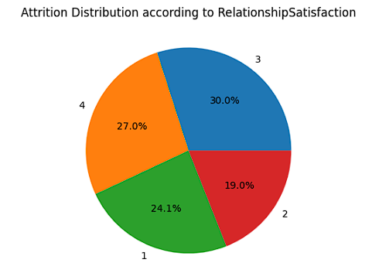

Fig. 2d Attrition Distribution by Relationship Satisfaction Score



Fig. 2e Attrition Distribution by Education Field

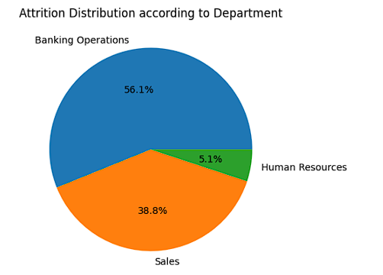

Fig. 2f Attrition Distribution by Department



Fig. 2g Attrition Distribution by Gender

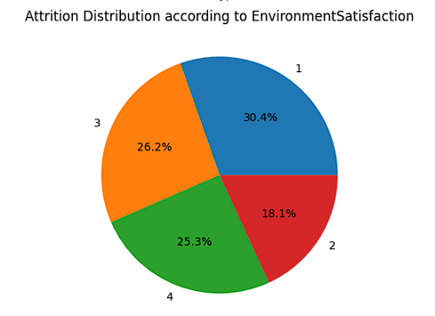

Fig. 2h Attrition Distribution by Environment Satisfaction Score

1. Line Charts

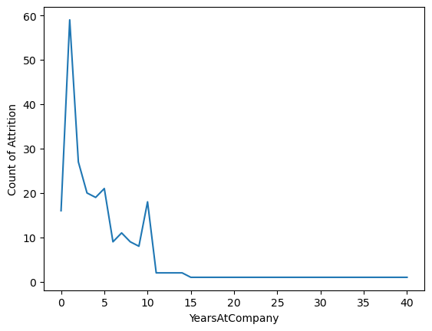

Fig. 3a Count of Incidence of Attrition by Number of Years at Company

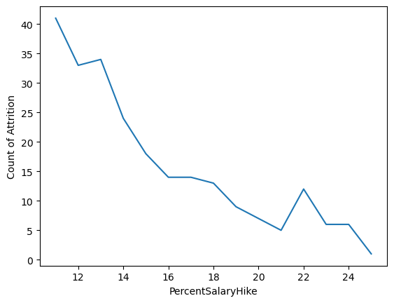

Fig. 3a Count of Incidence of Attrition by Level of Percent Salary Hike

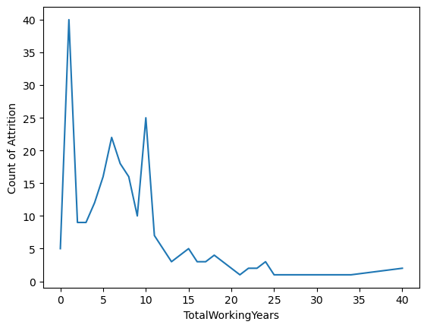Fig. 3a Count of Incidence of Attrition by Number of Total Working Years

1. OLAP Star Schema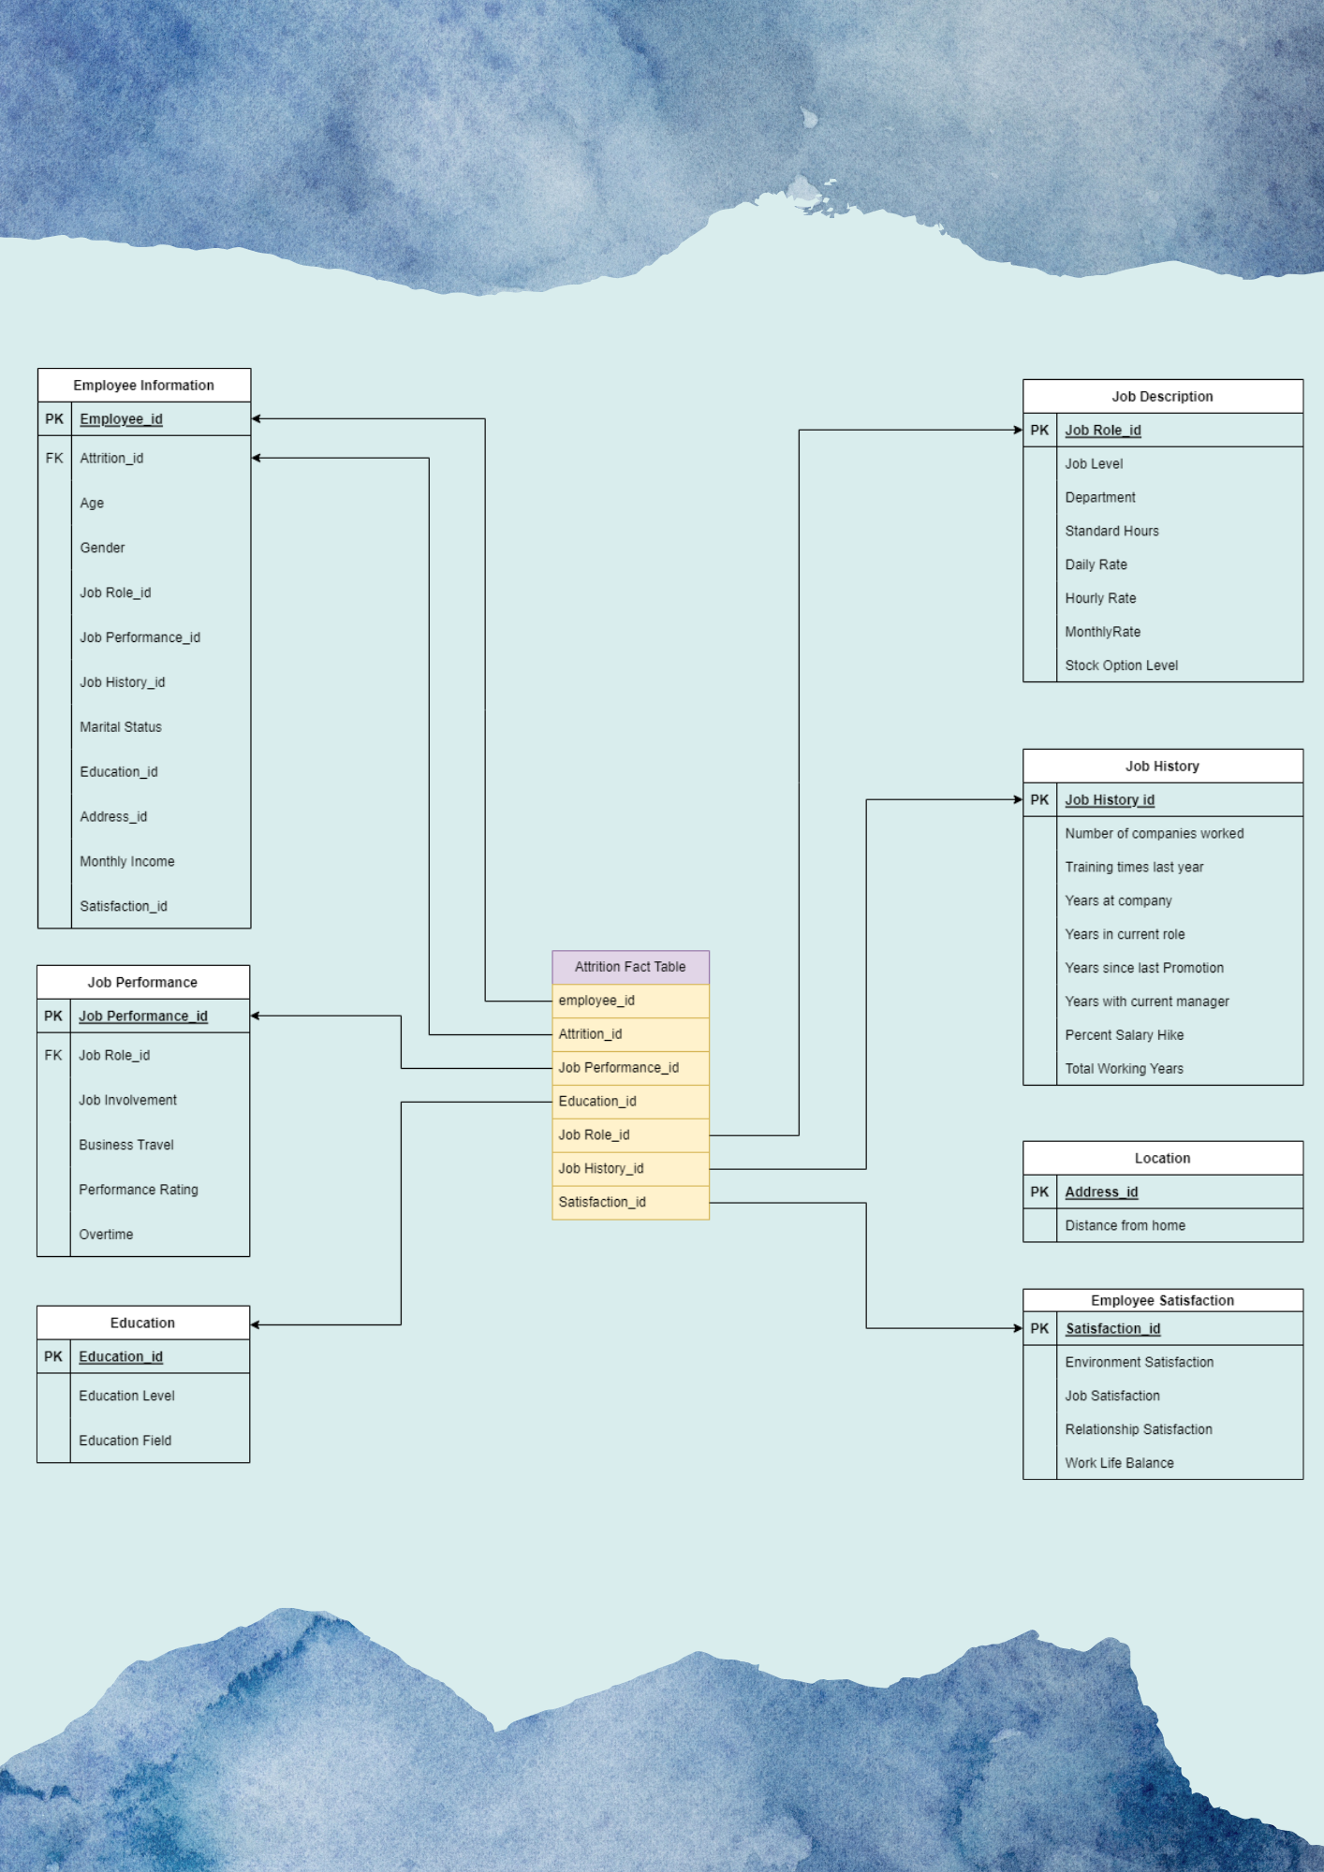

1. Feature Selection

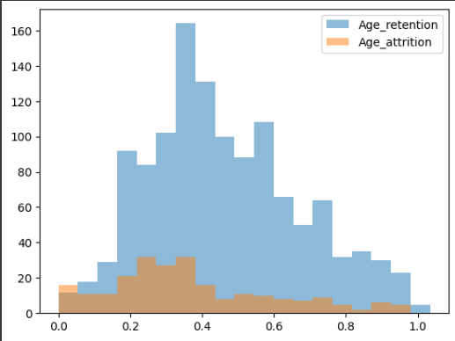

Fig. 5a Overlapping Histograms of Age Retention vs Age Attrition

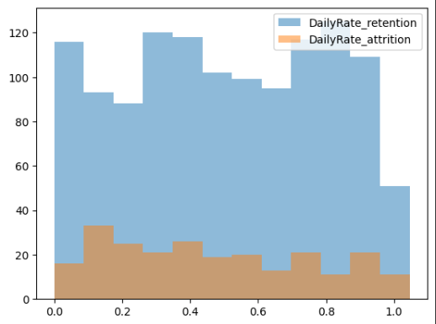

Fig. 5b Overlapping Histograms of Daily Rate Retention vs Daily Rate Attrition

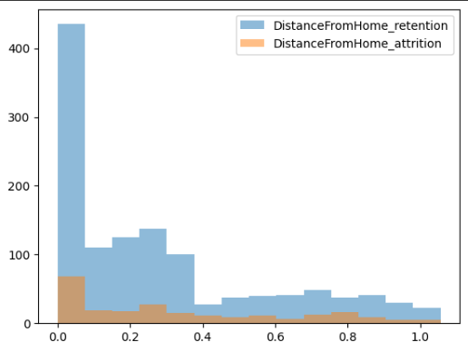

Fig. 5c Overlapping Histograms of Distance from Home Retention vs Distance from Home Attrition

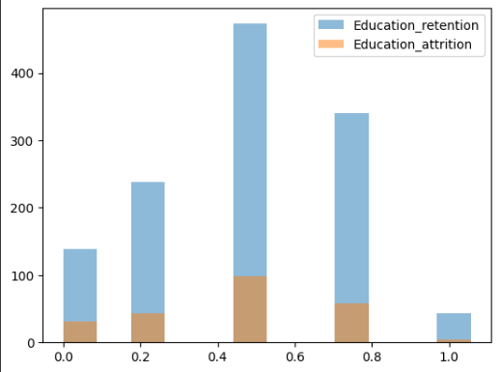

Fig. 5d Overlapping Histograms of Education Retention vs Edcuation Attrition

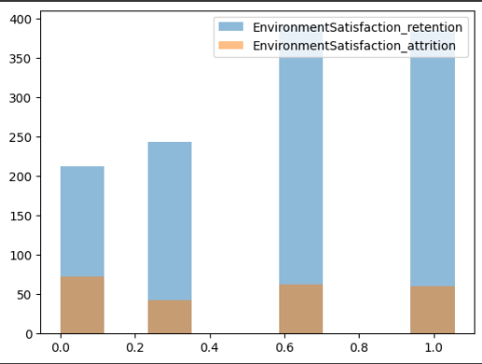

Fig. 5e Overlapping Histograms of Environment Satisfaction Retention vs Environment Satisfaction Attrition

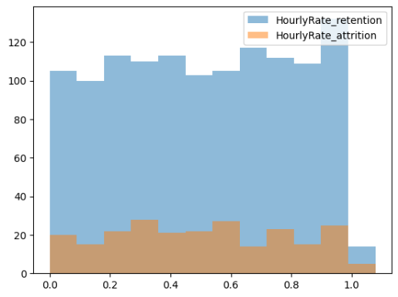

Fig. 5f Overlapping Histograms of Hourly Rate Retention vs Hourly Rate Attrition

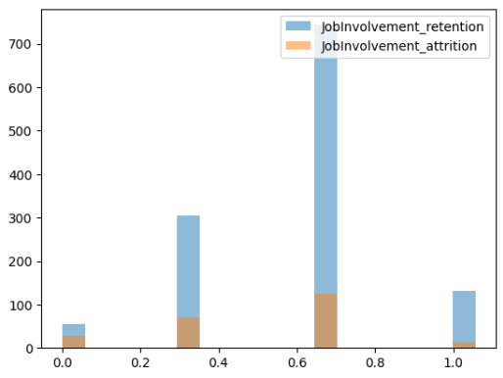

Fig. 5g Overlapping Histograms of Job Involvement Retention vs Job Involvement Attrition

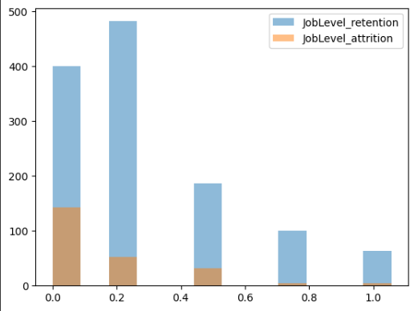

Fig. 5h Overlapping Histograms of Job Level Retention vs Job Level Attrition

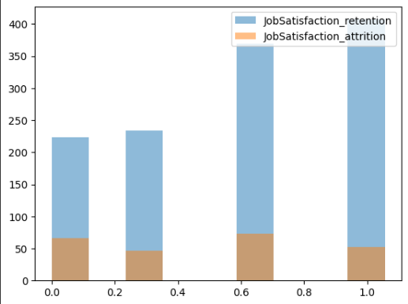

Fig. 5i Overlapping Histograms of Job Satisfaction Retention vs Job Satisfaction Attrition

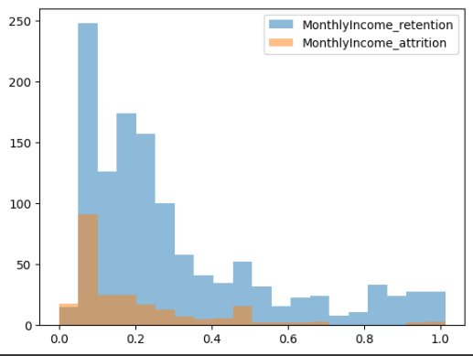

Fig. 5j Overlapping Histograms of Monthly Income Retention vs Monthly Income Attrition

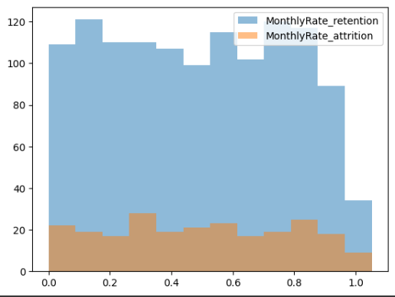

Fig. 5k Overlapping Histograms of Monthly Rate Retention vs Monthly Rate Attrition

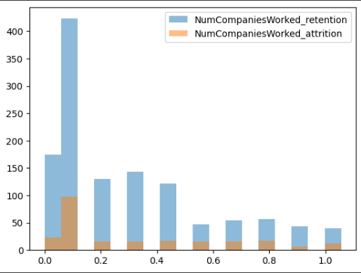

Fig. 5l Overlapping Histograms of Number of Companies Worked Retention vs Number Attrition

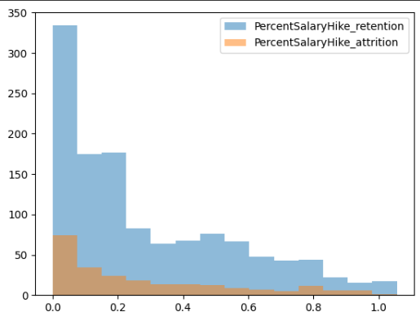

Fig. 5m Overlapping Histograms of Percent Salary Hike Retention vs Percent Salary Hike Attrition

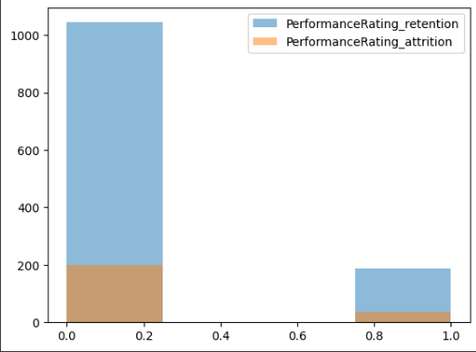

Fig. 5n Overlapping Histograms of Performance Rating Retention vs Performance Rating Attrition

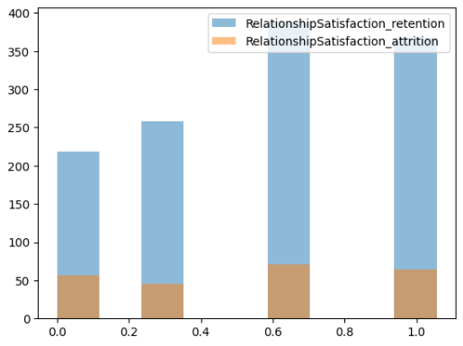

Fig. 5o Overlapping Histograms of Relationship Satisfaction Retention vs Relationship Satisfaction Attrition

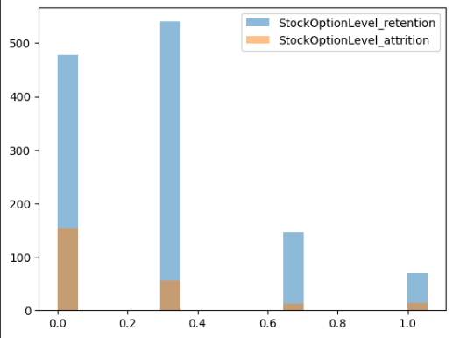

Fig. 5p Overlapping Histograms of Stock Option Level Retention vs Stock Option Level Attrition

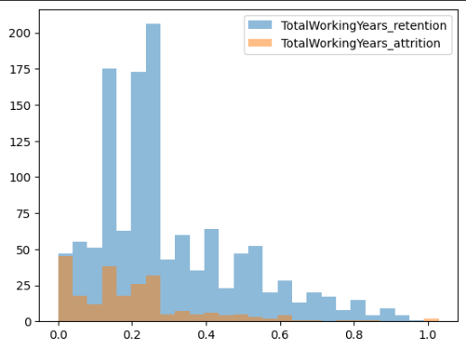

Fig. 5q Overlapping Histograms of Total Working Years Retention vs Total Working Years Attrition

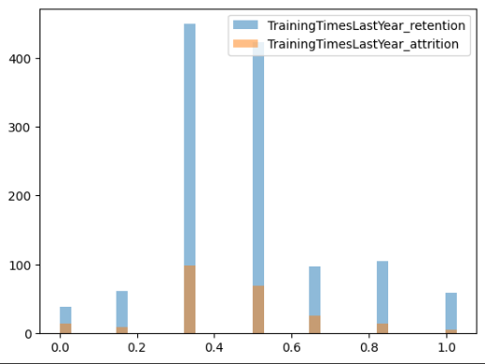

Fig. 5r Overlapping Histograms of Training Times Last Year Retention vs Training Times Last Year Attrition

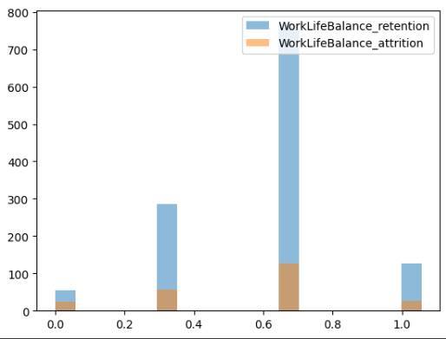

Fig. 5s Overlapping Histograms of Work Life Balance Retention vs Work Life Balance Attrition

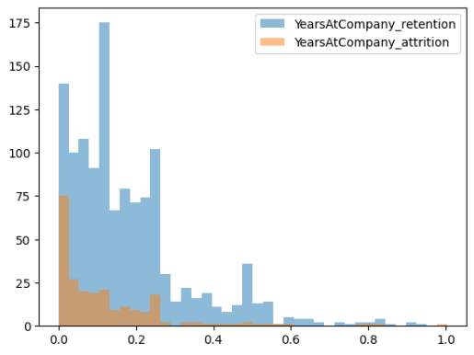

Fig. 5t Overlapping Histograms of Years at Company Retention vs Years at Company Attrition

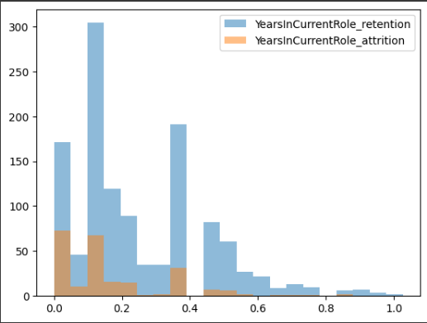

Fig. 5u Overlapping Histograms of Years in Current Role Retention vs Years in Current Role Attrition

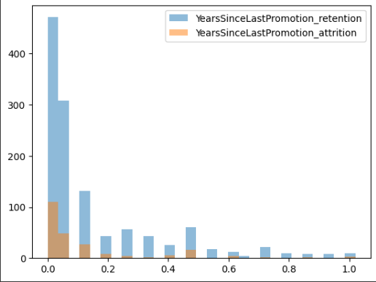

Fig. 5v Overlapping Histograms of Years since Last Promotion Retention vs Years since Last Promotion Attrition

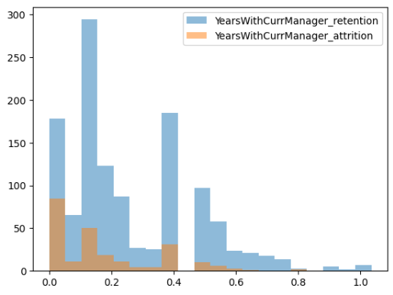

Fig. 5w Overlapping Histograms of Years with Current Manager Retention vs Years with Current Manager Attrition

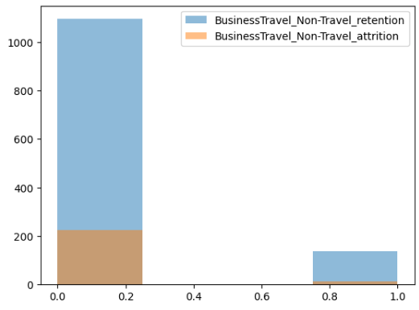

Fig. 5x Overlapping Histograms of Business Travel (Non-Travel) Retention vs Business Travel (Non-Travel) Attrition

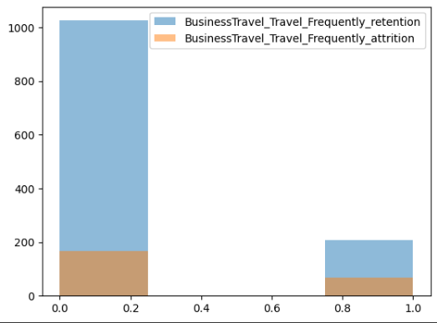

Fig. 5y Overlapping Histograms of Business Travel (Frequently) Retention vs Business Travel (Frequently) Attrition

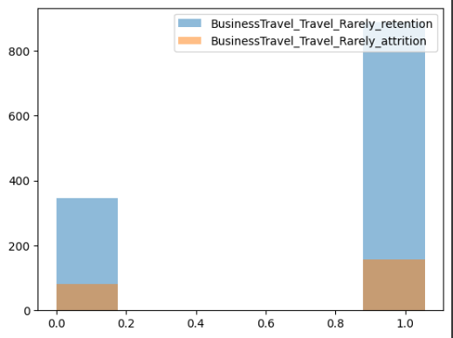

Fig. 5z Overlapping Histograms of Business Travel (Travel Rarely) Retention vs Business Travel (Travel Rarely) Attrition

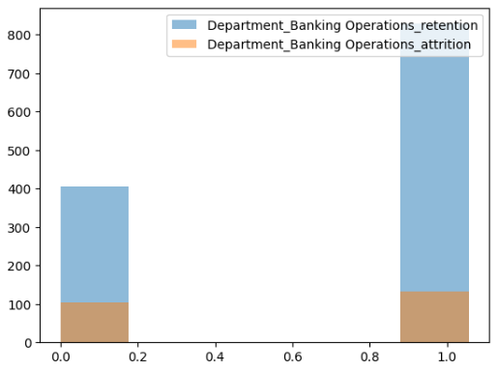

Fig. 5aa Overlapping Histograms of Department: Banking Operations Retention vs Department: Banking Operations Attrition

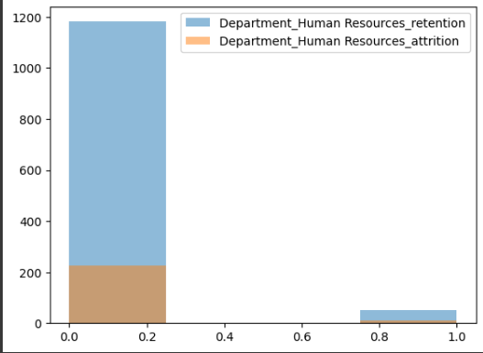

Fig. 5ab Overlapping Histograms of Deparment: Human Resources Retention vs Department: Human Resources Attrition

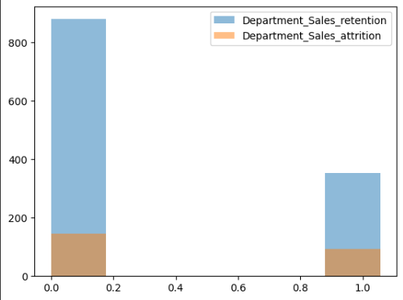

Fig. 5ac Overlapping Histograms of Department: Sales Retention vs Department: Sales Attrition

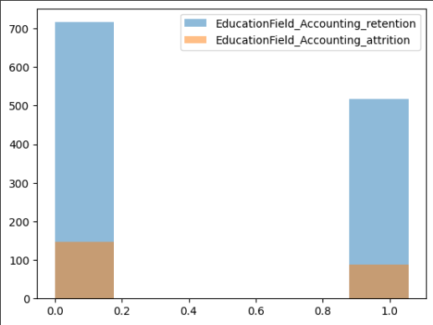

Fig. 5ad Overlapping Histograms of Education Field: Accounting Retention vs Education Field: Accounting Attrition

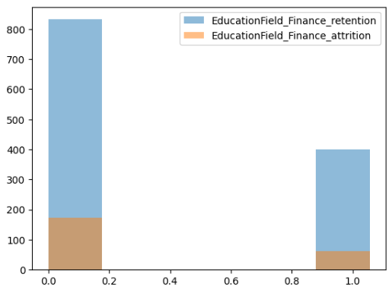

Fig. 5ae Overlapping Histograms of Education Field: Finance Retention vs Education Field: Finance Attrition

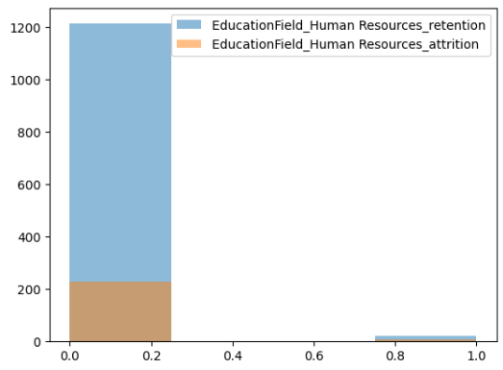

Fig. 5af Overlapping Histograms of Education Field: Human Resources Retention vs Education: Human Resources Attrition

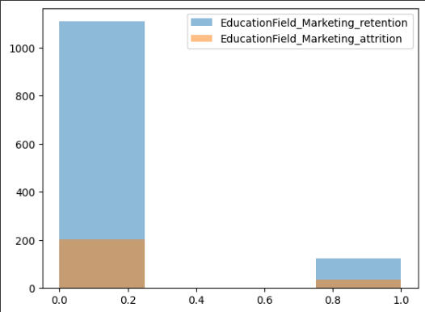

Fig. 5ag Overlapping Histograms of Education Field: Marketing Retention vs Education Field: Marketing Attrition

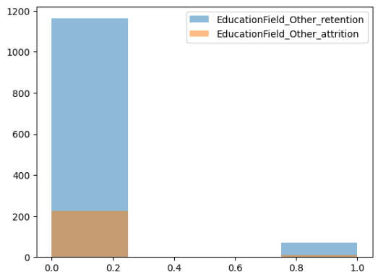

Fig. 5ah Overlapping Histograms of Education Field: Other Retention vs Education Field: OtherAttrition

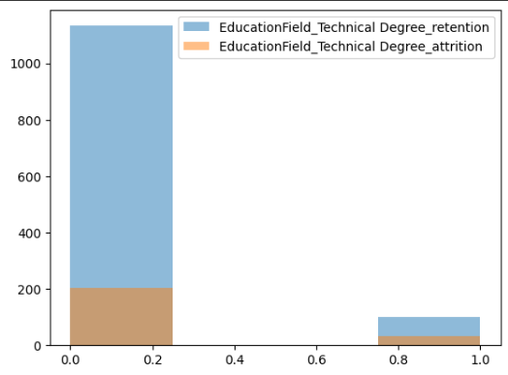

Fig. 5ai Overlapping Histograms of Education Field: Technical Degree Retention vs Education Field: Technical Degree Attrition

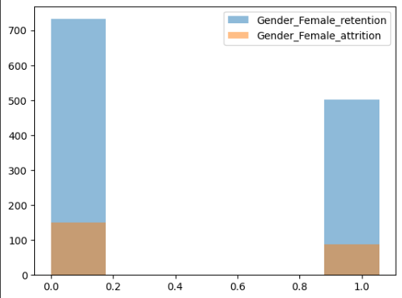

Fig. 5aj Overlapping Histograms of Female Retention vs Female Attrition

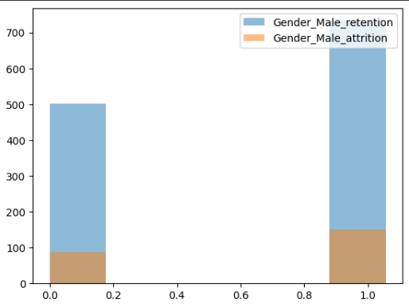

Fig. 5ak Overlapping Histograms of Male Retention vs Male Attrition

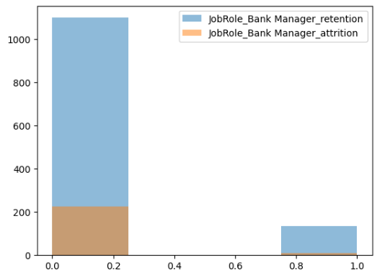

Fig. 5al Overlapping Histograms of Job Role: Bank Manager Retention vs Job Role: Bank Manager Attrition

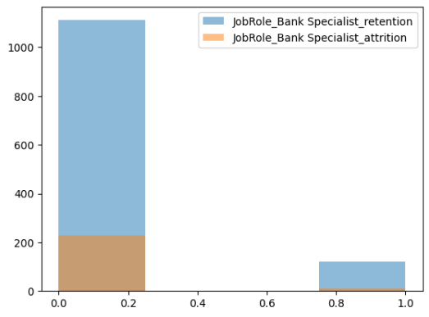

Fig. 5am Overlapping Histograms of Job Role: Bank Specialist Retention vs Job Role: Bank Specialist Attrition

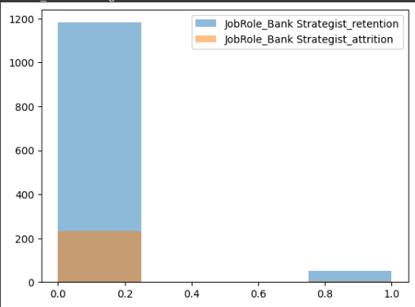

Fig. 5an Overlapping Histograms of Job Role: Bank Strategist Retention vs Job Role: Bank Strategist Attrition

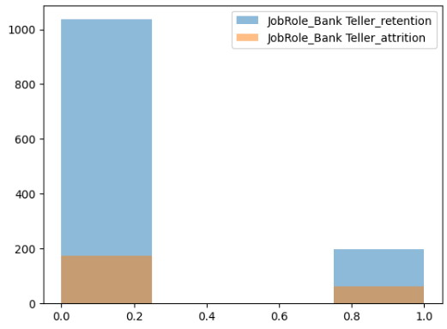

Fig. 5ao Overlapping Histograms of Job Role: Bank Teller Retention vs Job Role: Bank Teller Attrition

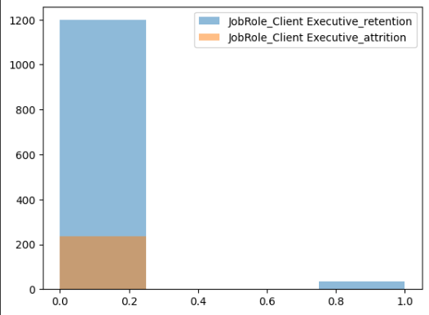

Fig. 5ap Overlapping Histograms of Job Role: Client Executive Retention vs Job Role: Client Executive Attrition

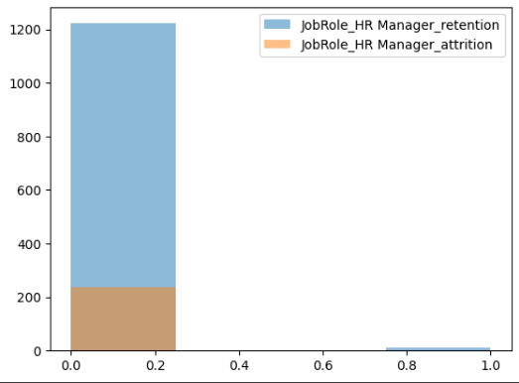

Fig. 5aq Overlapping Histograms of Job Role: HR Manager Retention vs Job Role: HR Manager Attrition

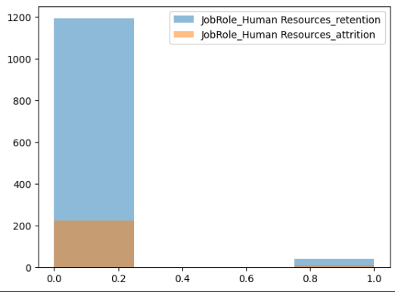

Fig. 5ar Overlapping Histograms of Job Role: Human Resources Retention vs Job Role: Human Resources Attrition

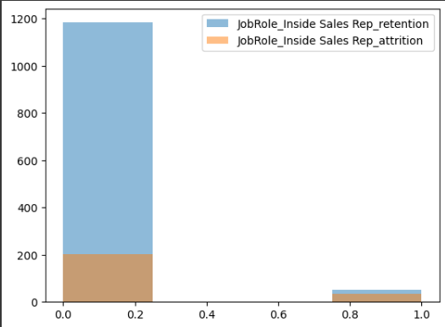

Fig. 5as Overlapping Histograms of Job Role: Inside Sales Rep Retention vs Job Role: Inside Sales Rep Attrition

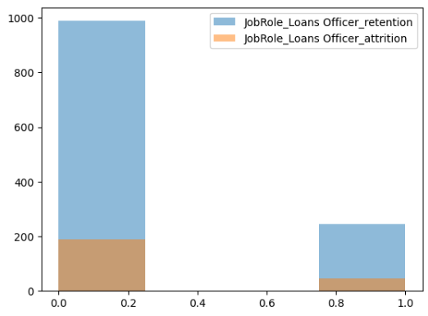

Fig. 5at Overlapping Histograms of Job Role: Loans Officer Retention vs Job Role: Loans Officer Attrition

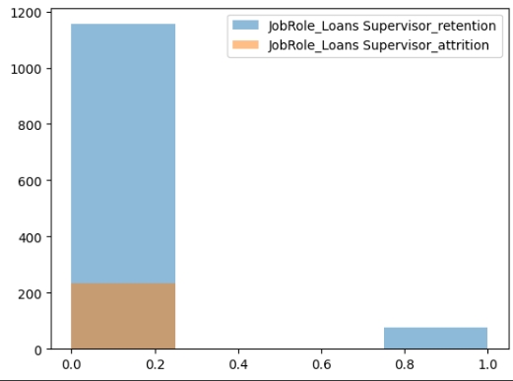

Fig. 5au Overlapping Histograms of Job Role: Loans Supervisor Retention vs Job Role: Loans Supervisor Attrition

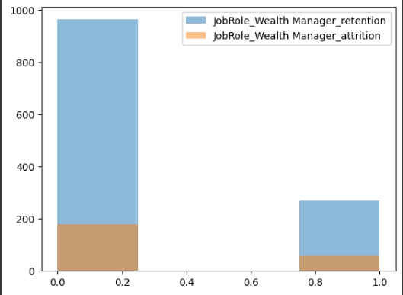

Fig. 5av Overlapping Histograms of Job Role: Wealth Manager Retention vs Job Role: Wealth Manager Attrition

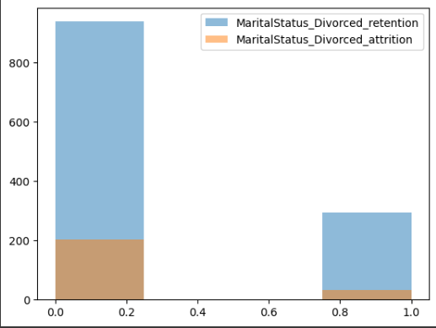

Fig. 5aw Overlapping Histograms of Marital Status: Divorced Retention vs Marital Status: Divorced Attrition

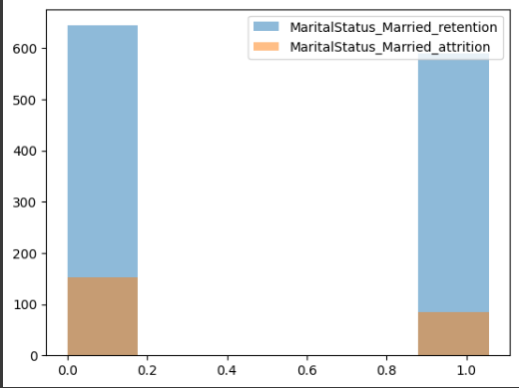

Fig. 5ax Overlapping Histograms of Marital Status: Married Retention vs Marital Status: Married Attrition

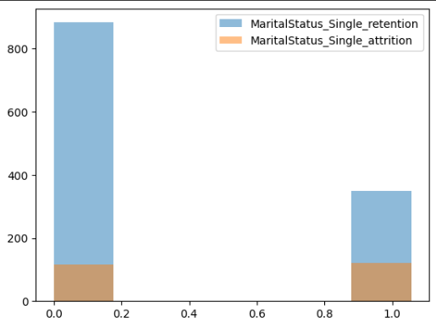

Fig. 5ay Overlapping Histograms of Marital Status: Single Retention vs Marital Status: Single Attrition

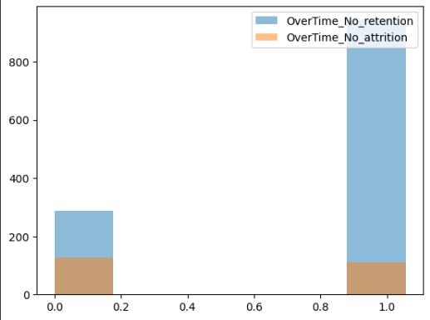

Fig. 5az Overlapping Histograms of with Overtime Retention vs with Overtime Attrition

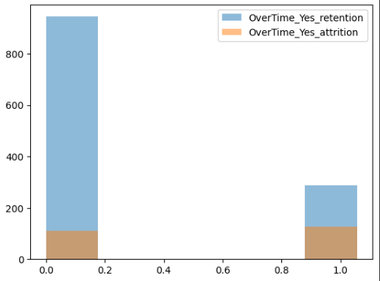

Fig. 5ba Overlapping Histograms of without Overtime Retention vs without Overtime Attrition

1. Scatterplot Matrix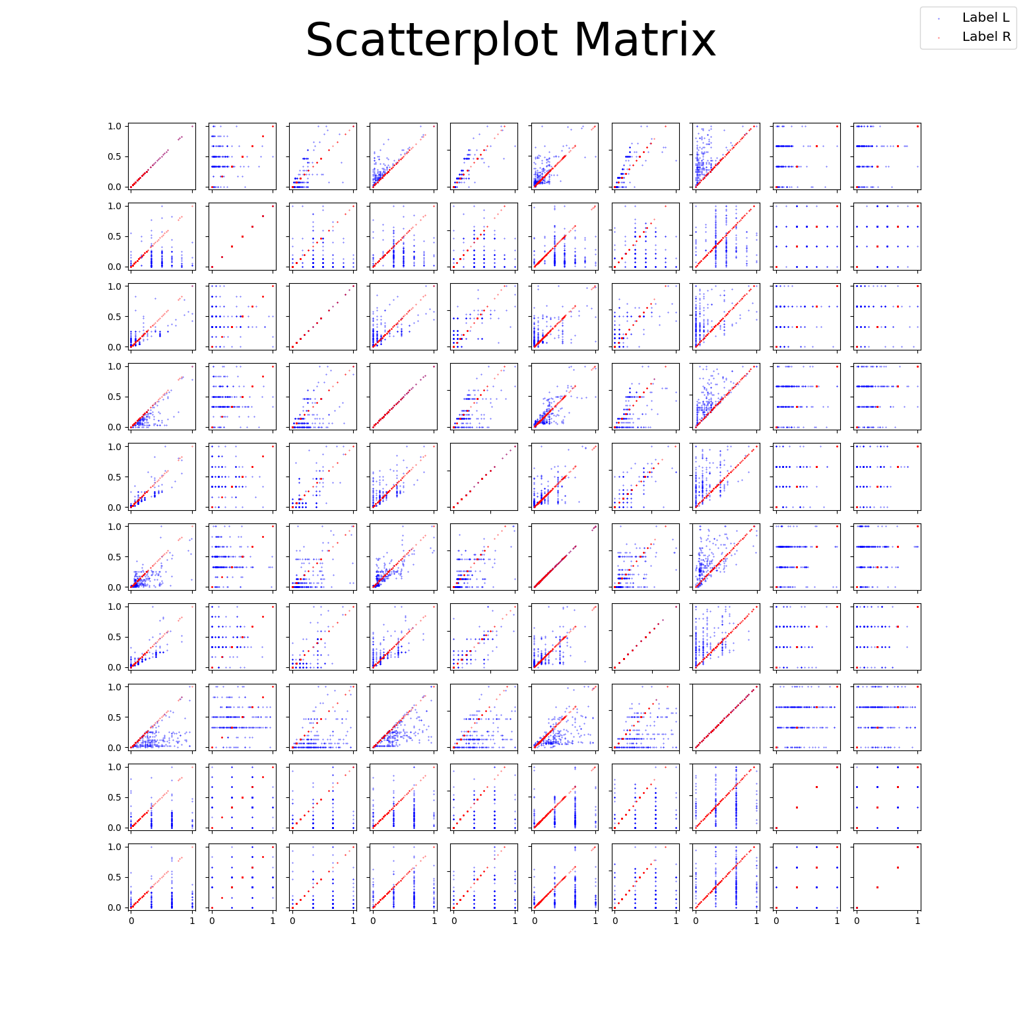
2. Parallel Lines

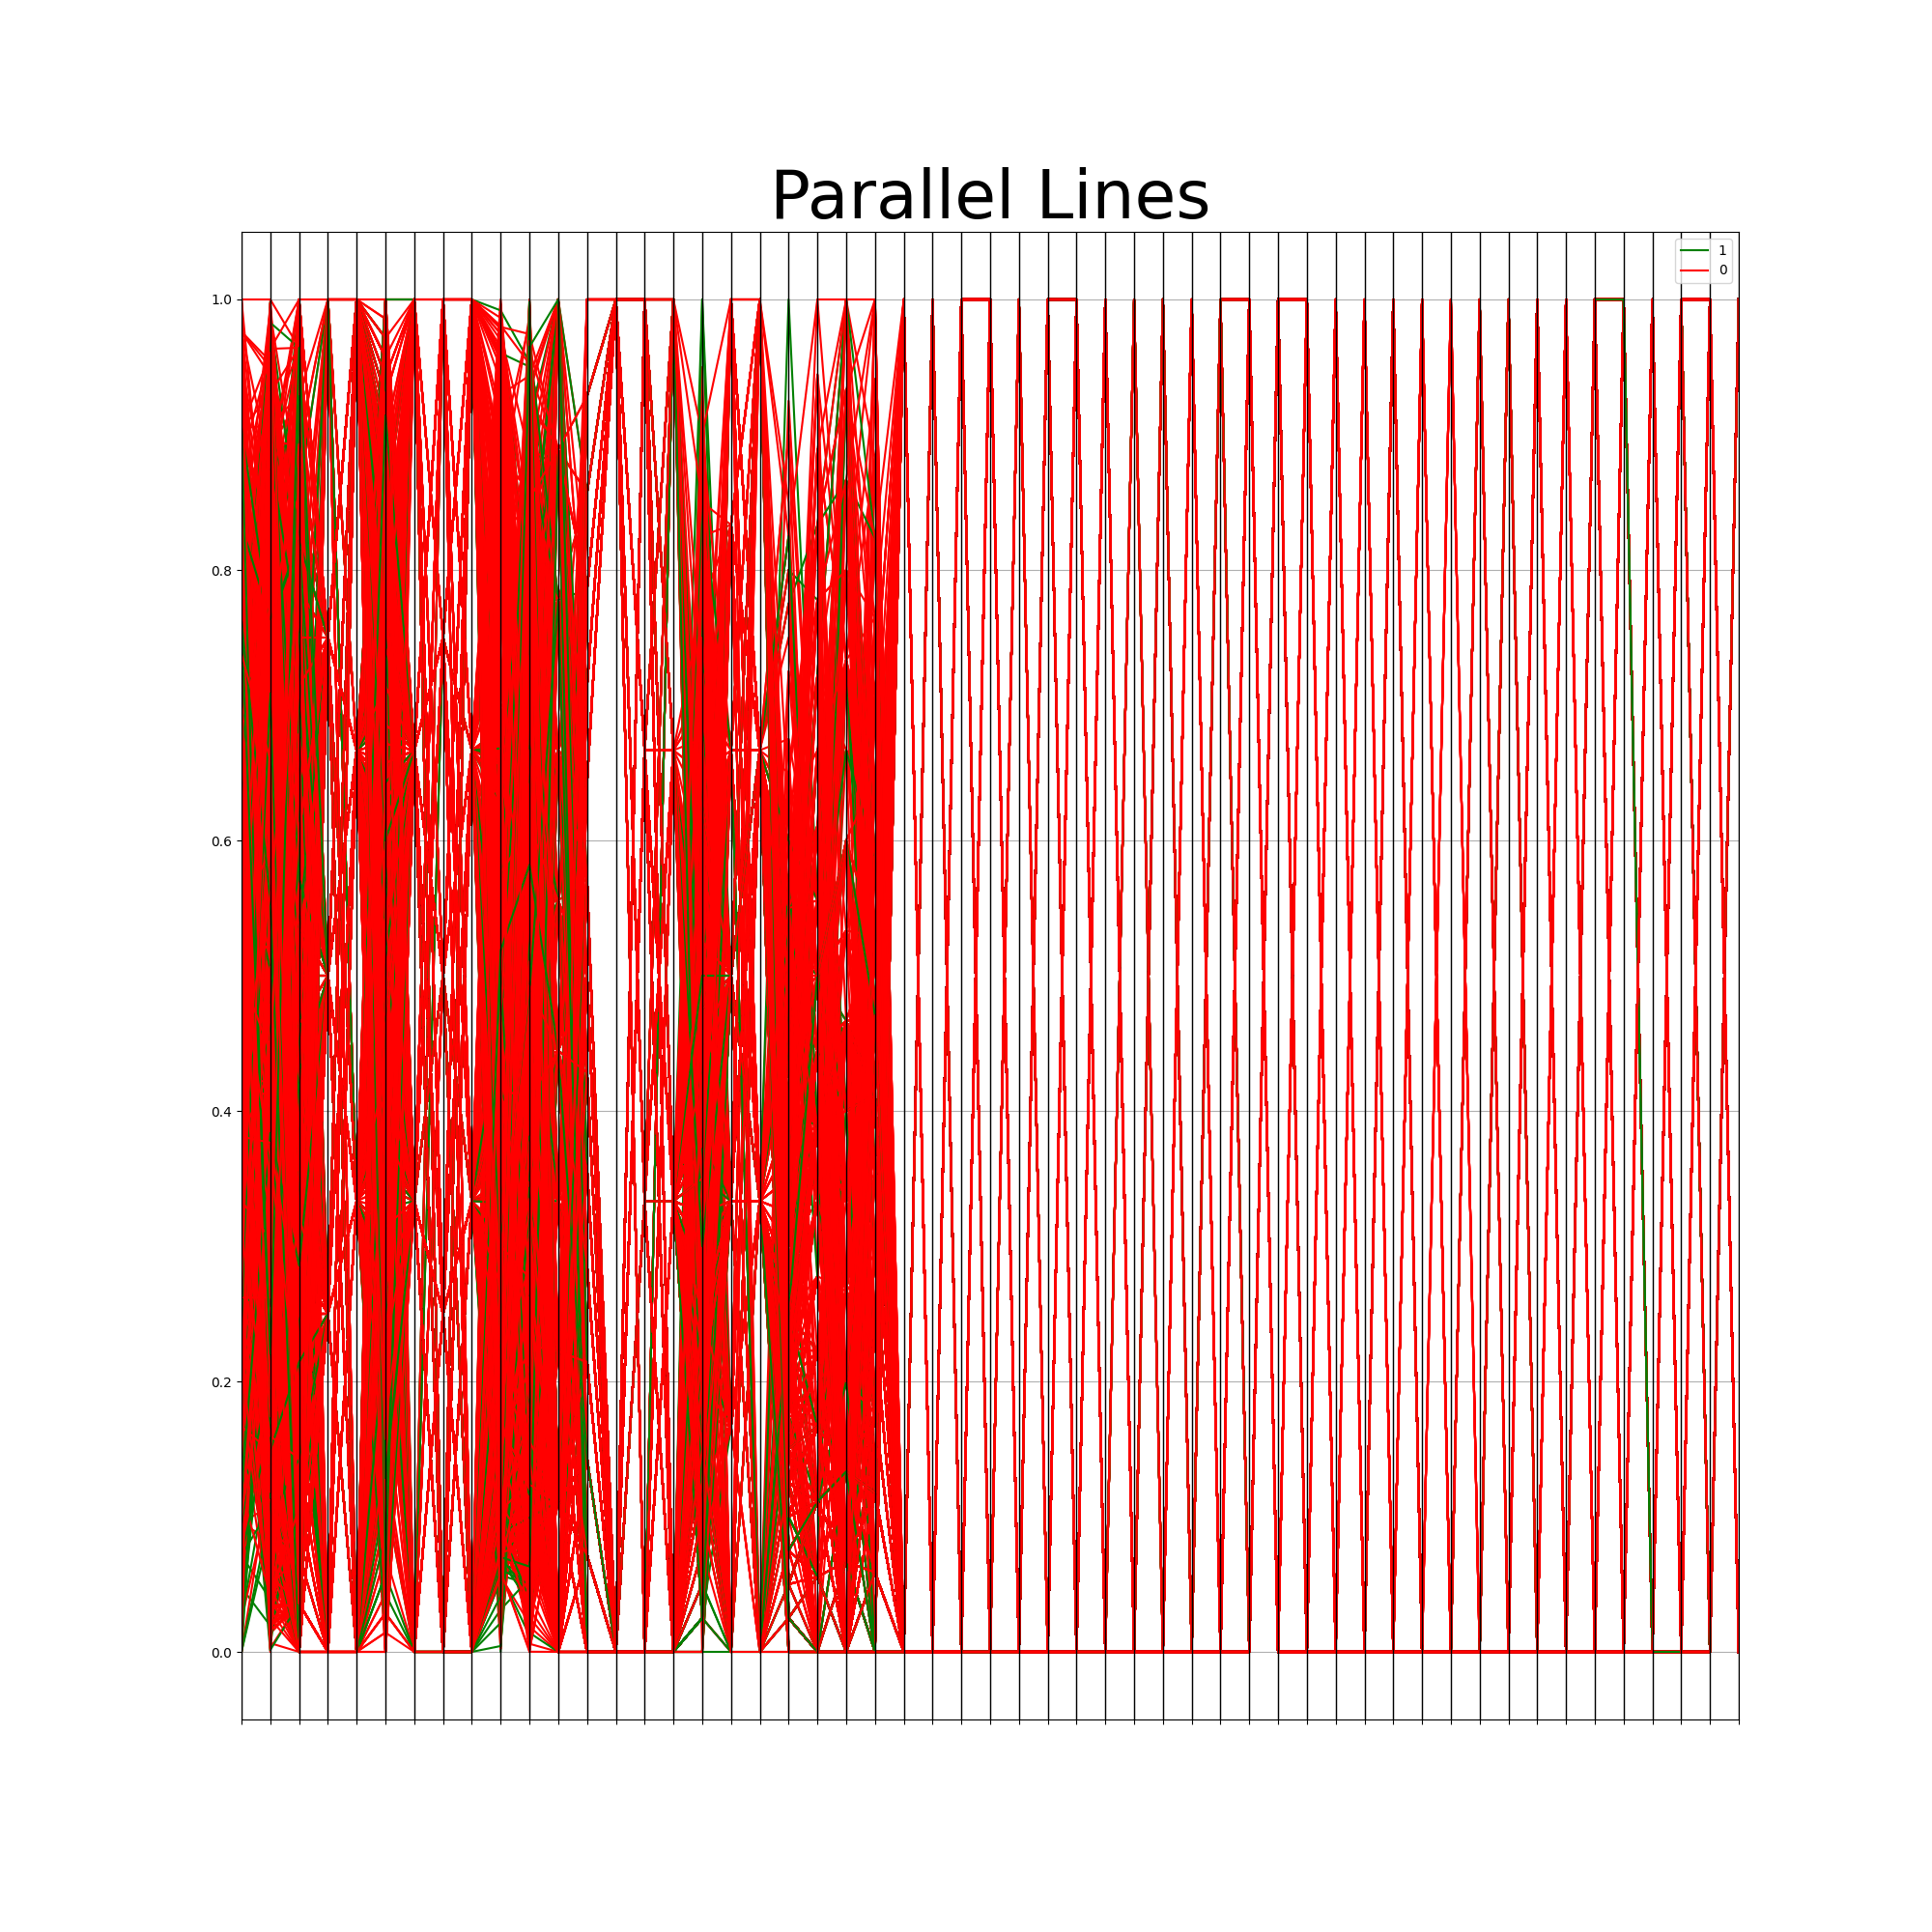

1. Modelling

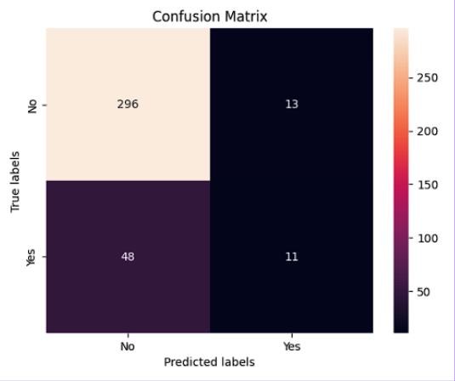

Fig. 8a Confusion Matrix for Gaussian Naive Bayes with Feature Selection (FS)

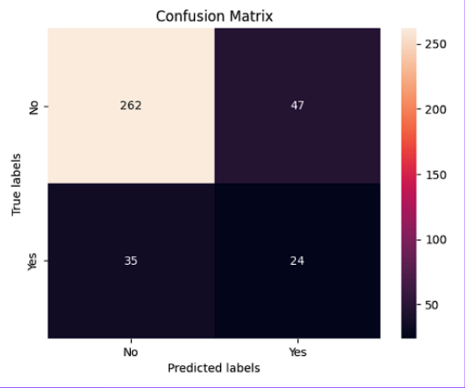

Fig. 8b Confusion Matrix for Multilayer Perceptron with Feature Selection (FS)

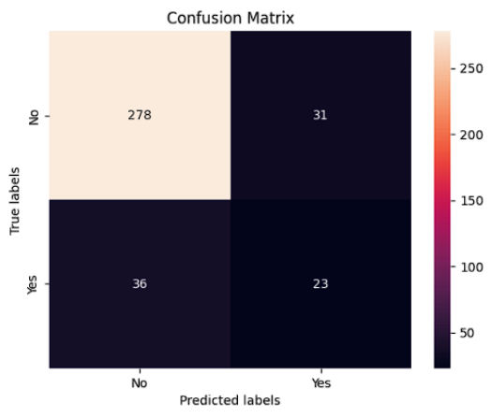

Fig. 8c Confusion Matrix for Multilayer Perceptron without Feature Selection

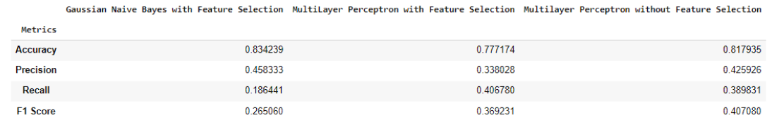

Fig. 8d Accuracy, Precision, Recall, and F1 Score Metric for Each Model

1. Dataset

Workforce Sustainability Dataset - Canvas